**Does carcass mass differ between blocks densities and does it then affect success?**

Data in excel file: ‘Mouse analysis’

It was then converted to a text document of the same name.

> mouse<-read.table(file.choose(), header=T)

> head (mouse)

Block Density Mass Success

1 A High 20.67 Y

2 A High 21.62 Y

3 A Med 20.17 Y

4 A Med 21.24 Y

5 A Med 20.30 Y

6 A Med 20.02 Y

Now check for means, ranges, sample sizes and variation in mass.

> summary (mouse)

Block Density Mass Success

A:21 High: 8 Min. :19.35 N: 6

B:19 Low :49 1st Qu.:20.04 Y:73

C:19 Med :22 Median :20.64

D:20 Mean :20.61

3rd Qu.:21.27

Max. :21.97

**Mean: 20.61**

**Ranges: 19.35 – 21.97 (2.62)**

> var (mouse$Mass)

**[1] 0.5162166**

Now we run a GLM to see if any of this variation in mass is explained by Block, Density or success. This will tell us if the carcass mass differed between blocks or densities which is a crucial assumption of the experiment and its randomisation. Also it show if there is a link between mass and success which would allow us to do a Chi2 if not present.

Maximal Model

model1<- lm(Mass~Block+Density+Success+Block*Success+Density*Success, data=mouse)

For some reason both interactions do not display so remove the success interactions

model1<-lm(Mass~Block+Density+Success+Density*Block, data=mouse)

summary (model1)

anova (model1, test="F")

**Results**

> anova (model1, test="F")

Analysis of Variance Table

Response: Mass

Df Sum Sq Mean Sq F value Pr(>F)

Block 3 3.175 1.05837 2.0959 0.1092

Density 2 0.077 0.03874 0.0767 0.9262

Success 1 0.372 0.37156 0.7358 0.3941

Block:Density 6 3.312 0.55201 1.0931 0.3758

Residuals 66 33.329 0.50498

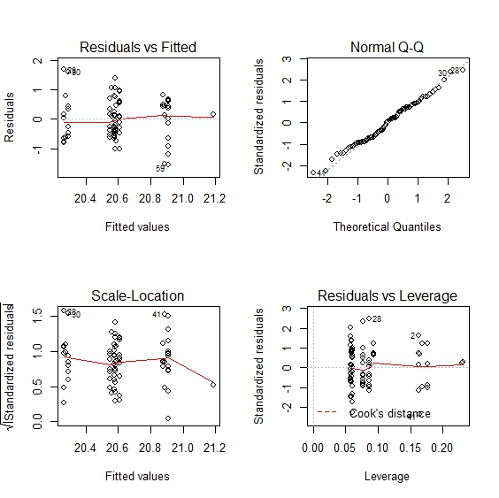This model did not violate ant of the assumptions of normality or homogeneity of variance.

No effect of any factor on mass.

Then the model was simplified using the step transformation.

model2<-step(model1)

Which gave a minimal model including only Density.

This was still not significant:

Response: Mass

Df Sum Sq Mean Sq F value Pr(>F)

Block 3 3.175 1.05837 2.1402 0.1022

Residuals 75 37.090 0.49453

**Conclusion**

The mouse carcass mass did not differ between the four blocks (F3, 66 = 2.096, p = 0.11) or the three density treatments (F2, 66 = 0.08, p = 0.93). There was no effect of success on the carcass mass either (F1, 66 = 0.74, p = 0.4) so if a brood was successful or not did not depend on the carcass mass. There was no interaction either (F6, 66=1.093, p=0.38)

This shows that the randomisation procedure used in the experiment was appropriate and justifies the exclusion of mouse/carcass/brood from the later models.